**Film - Rental**

There is a film rental store that provides DVDs on a rental basis. The owner of this store is your friend and he is not at all computer savvy. To manage his business he has software that helps him to manage the business.

He also has one helper who understands computers well and as a part-time job, he manages the software and helps the owner by providing different types of reports using SQL queries.

Today, unfortunately, this helper is not available. So your friend has called you to help him with some of the reports that he needs to make important business decisions.

**Schema Information**

Before you can help your friend it is very important for you to understand the schema. This schema contains a number of tables that relate to the various aspects of this store, such as the films available for rent, the customers who rent them, and the staff who manage the store and the rental process.

The tables in the database are interrelated, which allows them to run complex queries for data analysis.

Following is a brief description of a few of the tables

**Actor** table contains information about the actors who have appeared in films, as well as information about the specific films in which they have appeared.

**The film** table provides information about the films themselves, including their category, language, and other details.

**The customer** Info table contains information about the customers who rent DVDs from the store, including their addresses and other personal information.

Finally, the **Store** table contains information about the store itself, including details about the staff who work there, the rentals that are available, and the payments that are made by customers.

**ER Diagram:**

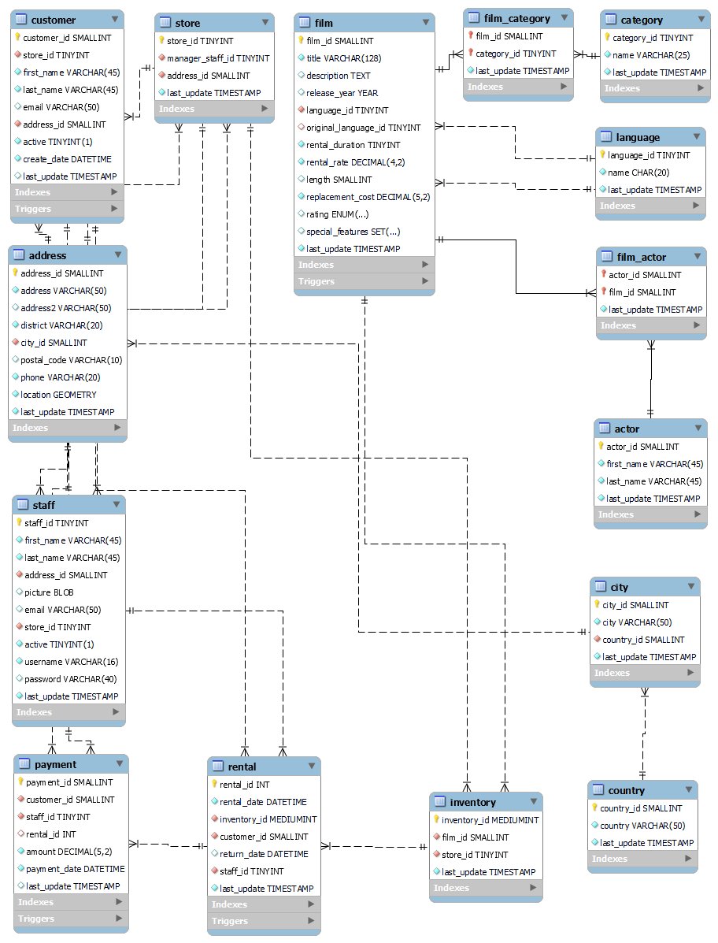

**Overview of Tables:**

|  |  |
| --- | --- |
| Actor Info | Actor **|** Film_Actor |
| Film Info | Film **|** Film_Category **|** Category **|** Language |
| Customer Info | Customer **|** Address **|** City **|** Country |
| Store Info | Store **|** Staff **|** Rental **|** Payment |

**Tables Structure:**

|  |  |
| --- | --- |
| **Actor**   * actor_id * first_name * last_name | **Film_Actor**   * actor_id * film_id |
| **Language**   * language_id * name | **Film_category**   * film_id * category_id |
| **Film**   * film_id * title * description * language_id * rental_duration * rental_rate * length * replacement_cost * rating | **Staff**   * staff_id * first_name * last_name * address_id * email * store_id |
| **Category**   * category_id * name | **Country**   * country_id * country |
| **Customer**   * customer_id * store_id * first_name * last_name * email * address_id | **Address**   * address_id * district * city_id * postal_code * phone * location |
| **City**   * city_id * city * country_id | **Store**   * store_id * manager_staff_id * address_id |
| **Rental**   * rental_id * rental_date * inventory_id * customer_id * return_date * staff_id | **Payment**   * payment_id * customer_id * staff_id * rental_id * amount * payment_date |

**Instructions:**

1. Create these tables in the database by running the “schema.sql” script.
2. Populate these tables in the database by running the “data.sql” script.

**Questions:**

1. What is the total revenue generated from all rentals in the database? **(2 Marks)**
2. How many rentals were made in each month_name? **(2 Marks**)
3. What is the rental rate of the film with the longest title in the database? **(2 Marks)**
4. What is the average rental rate for films that were taken from the last 30 days from the date("2005-05-05 22:04:30")? **(2 Marks)**
5. What is the most popular category of films in terms of the number of rentals? **(3 Marks)**
6. Find the longest movie duration from the list of films that have not been rented by any customer. **(3 Marks)**
7. What is the average rental rate for films, broken down by category? **(3 Marks)**
8. What is the total revenue generated from rentals for each actor in the database? **(3 Marks)**
9. Show all the actresses who worked in a film having a "Wrestler" in the description. **(3 Marks)**
10. Which customers have rented the same film more than once? **(3 Marks)**
11. How many films in the comedy category have a rental rate higher than the average rental rate? **(3 Marks)**
12. Which films have been rented the most by customers living in each city? **(3 Marks)**
13. What is the total amount spent by customers whose rental payments exceed $200? **(3 Marks)**
14. Display the fields which are having foreign key constraints related to the "rental" table. [Hint: using Information_schema] **(2 Marks)**
15. Create a View for the total revenue generated by each staff member, broken down by store city with the country name. **(4 Marks)**
16. Create a view based on rental information consisting of visiting_day, customer_name, the title of the film, no_of_rental_days, the amount paid by the customer along with the percentage of customer spending. **(4 Marks)**
17. Display the customers who paid 50% of their total rental costs within one day. **(5 Marks)**